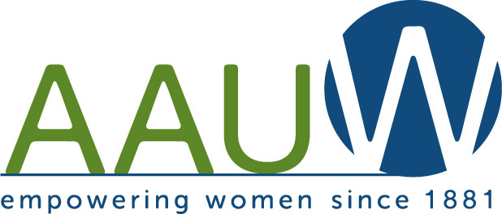
To: NYS Board Members
From: Joan Monk
Date: July 2014
Re: Special Project
NY/NJ WILD (Women In Leadership Development) Project
Happy Birthday, Eleanor! – Celebrating International Day of the Girl
October 11th, 2014
There is no better way to honor the legacy of Eleanor Roosevelt than promoting this celebration of girls that falls on her birthday, October 11th. 2014 is the third year of celebration & we want to spread the word.

- Background Information on International Day of the Girl
- The Girl Effect
- Create an Eleanor Roosevelt Birthday Club
- Get Girls Involved in National Model UN - NMUN Conferences
- Get Girls Involved in Leadership
- Let’s Hear It For The Girls – 11 Girls Everyone Should Know!
- 11 Days/Weeks/Months of Action in honor of ER & International Day of the Girl*
- Primer on Girls Issues*
- Individual/Personal Plan of Action
- Branch Plan of Action to Honor Eleanor/Celebrate International Day of the Girl
- 11 Additional Resources
- Booklist
- Movies Popular
- You-tube Videos
- ER’s Most Popular Quotes
- Readers Theatre Script
- Articles of Interest
- 11 Girls Everyone Should Know
- ER Papers Project - http://www.gwu.edu/~erpapers/
- Community Connections – Girltopia and AAUW Connects @ YWCA
- Merry Christmas, ER
- The Christmas Story by Eleanor Roosevelt
I look forward to hearing from you with questions/concerns/progress as we celebrate
International Day of the Girl throughout NYS. Thanks for all you do to grow AAUW NYS,
Joan Monk, AAUW NYS Special Projects Director (ftmaven@gmail.com or 914-245-7704)

